Specifications
  - END-ADU-0003 2025: Customer column can be searched and sorted in orders, quotes and invoices for parts
Doc Version 1.0

Customer: | Guntram End GmbH
Project: | Optimization Phase
Proalpha version: | 9.3.0
Proalpha Installation(s): | DE
GUI language: | German
Author: | Steffen Scheil
Created on: | 25.03.2025
Last change on: | 08.04.2025
Contact Customer: | Oliver Klinkenberg

This document describes a modification or expansion of the standard software Proalpha and has been checked by the customer. The functional design in chapters 2 - 4 is hereby released for technical specification and costing in compliance with the requirements in section "Final Provisions":

......................................................
Date and Signature of Customer

Contents
1. [UPDATE THE TABLE] 3
1.1 [UPDATE THE TABLE] 3
1.2 [UPDATE THE TABLE] 3
1.3 [UPDATE THE TABLE] 3
1.4 [UPDATE THE TABLE] 3
2. [UPDATE THE TABLE] 4
2.1 [UPDATE THE TABLE] 4
2.1.1 [UPDATE THE TABLE] 6
2.2 [UPDATE THE TABLE] 6
3. [UPDATE THE TABLE] 8
3.1 [UPDATE THE TABLE] 8
3.2 [UPDATE THE TABLE] 9
4. [UPDATE THE TABLE] 11
4.1 [UPDATE THE TABLE] 11
4.2 [UPDATE THE TABLE] 11
4.3 [UPDATE THE TABLE] 11
5. [UPDATE THE TABLE] 12
5.1 [UPDATE THE TABLE] 12
5.1.1 [UPDATE THE TABLE] 12
5.1.2 [UPDATE THE TABLE] 12
5.1.3 [UPDATE THE TABLE] 12
6. [UPDATE THE TABLE] 13
7. [UPDATE THE TABLE] 14
7.1 [UPDATE THE TABLE] 14
7.2 [UPDATE THE TABLE] 14
8. [UPDATE THE TABLE] 15

Requirements

References
The specification sheet is based on a requirement from 2018, which is now being implemented. The requirements were added in a workshop with Mr. Klinkenberg and Mr. Flügge on 25.03.2025.

Summary and Objectives
In the "Quotes Part", "Orders Part" and "Invoices Part" browser, the "Customer" column is to be sortable and the search function is to be available. The browser can be opened via the "Parts (Info) | Sales" program and via sales document lines > Info > "Parts (Info) " | Sales
ในหน้าต่างเรียกดู “ใบเสนอราคา (อะไหล่)” “ใบสั่งซื้อ (อะไหล่)” และ “ใบแจ้งหนี้ (อะไหล่)” คอลัมน์ ‘ลูกค้า’ ควรสามารถเรียงลำดับได้ และควรมีฟังก์ชันการค้นหาให้ใช้งานได้ สามารถเข้าถึงหน้าต่างเรียกดูได้ผ่านเมนู “อะไหล่ (ข้อมูล) | การขาย” และผ่านทาง รายการเอกสารการขาย > ข้อมูล > “อะไหล่ (ข้อมูล)” | การขาย

Description of requirements
Since the "Customer" column in the browser for "Quotes Part", "Orders Part" and "Invoices Part" can be searched and sorted, it is easier to find a quote, order or invoice for a customer.

Requirements Glossary (Terminology)

Term | Explanation
Table 1Requirements Glossary

Functional design

Description of the solution
- Adjustment in the "Quotes Part", "Orders Part" and "Invoices Part" browser, which is opened via the "Parts (Info)" > "Sales" > Quote | Order | Invoice program. The program and browser concerned are exemplified in the following with screenshots for the quote.
The customizations of the browser apply analogously to:
- Parts (Info) > Sales > Quote
- Parts (Info) > Sales > Order
- Parts (Info) > Sales > Invoice

- Implemented in all current companies
- The "Customer" column should be sortable into the browser and the search function should also be possible (reference: function similar to the standard function in the Document Number column in the same browser).
- Adjustment is made in browsers "Quotes Part", "Orders Part" and "Invoices Part" for the "Customer" column (the column has been selected in the screenshot of an example below)
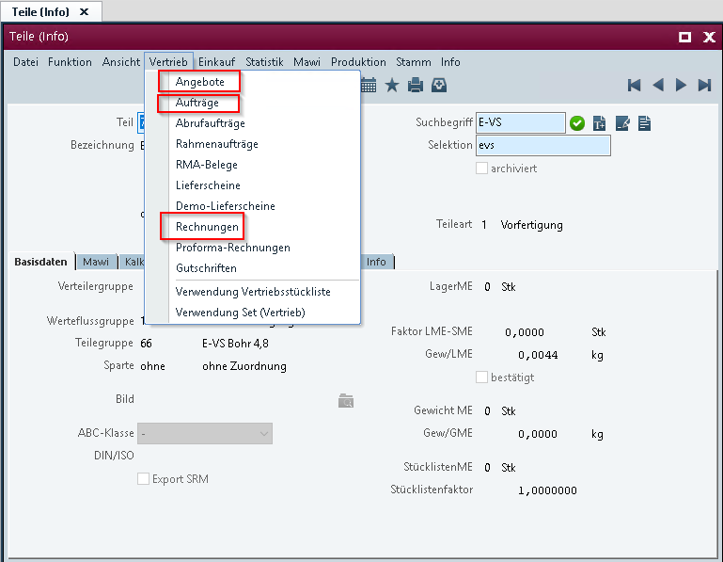
Mapping 1Example: Opening the browser for quotes, orders and invoices
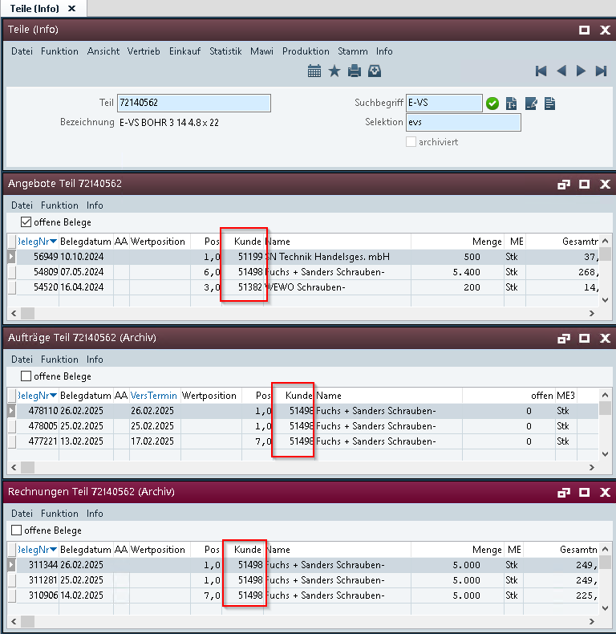
Mapping 2Example: "Customer" column can be searched and sorted with the new function.

- If the "Parts (Info)" program is opened with a sales document line, the "Customer" column in the "Quotes Part", "Orders Part" and "Invoices Part" browsers must also be searchable and sortable.
The adjustments also apply to the sales document lines:
- Quote
- Order
- Invoice
The following screenshot shows an example of the "Parts (Info)" program call for the sales document line using the example of the sales document line of a quote.

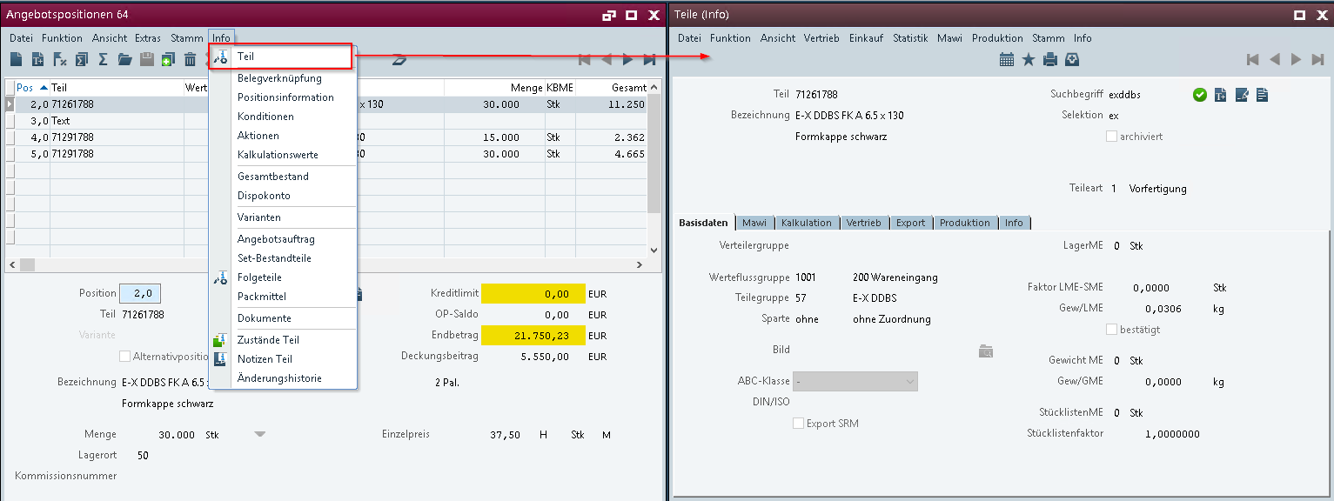
Mapping 3Example: Opening "Parts (Info)" via the quote line
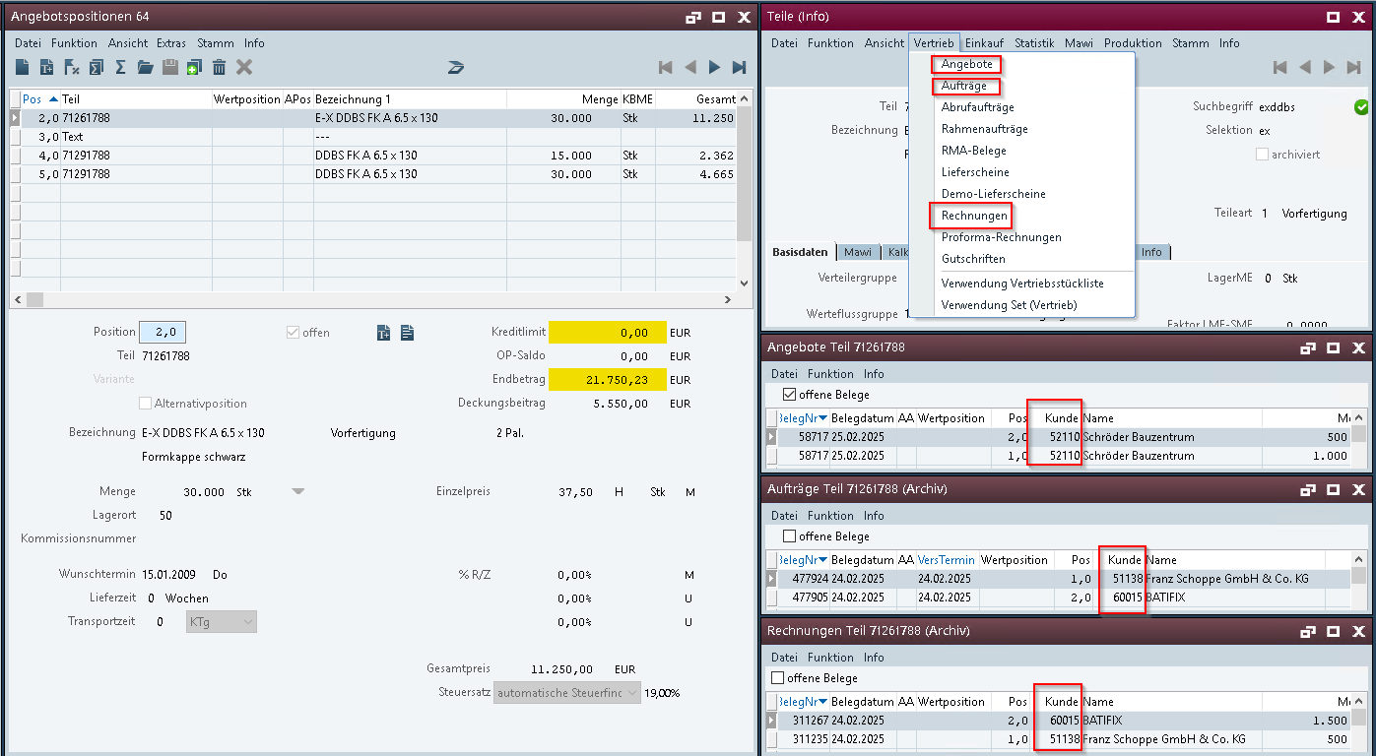
Mapping 4Example: Opening the browser "Quotes Part, "Orders Part" and "Invoices Part" via "Parts (Info)" from the quote line with the column "Customer" (can be searched and sorted)

<Template for Section>

Business Logic & GUI

Data Model

Output

Differentiation
The customization refers to the tables, fields and programs mentioned.
This specification sheet does not automatically add functional extensions to the adjacent modules of the Proalpha environment, such as the DMS, Analyzer, reports, and forms. The Proalpha help is not automatically expanded.
Changes to adjacent modules/programs must be described and defined in the specifications sheet. It also includes changes to the graphical user interface. If Ray is not explicitly mentioned here, the present modification refers to the Classic Proalpha client.

Test cases
The specified test cases map the customization described here and are the basis for the acceptance of the software.

Check via "Parts (Info)" Search and sort "Customer" column
Pt | Explanation | Expected result | Test data
 | Check Parts (Info) > Sales | Quotes | Open the "Parts (Info)" program > Sales | Quotes  Browser with list for "Quotes Part" opens | "Customer" column:  - The sort function and search function are available and can be used (Reference function is the same as for the Document Number column) | Test 1  Company 100  Part: 72140562
 | Test result (incl. screenshots)
 | Check Parts (Info) > Sales | Orders | Open the "Parts (Info)" program > Sales | Orders  Browser with list for "Orders Part" opens | "Customer" column:  - The sort function and search function are available and can be used (Reference function is the same as for the Document Number column) | Test 1  Company 100  Part: 72140562
 | Test result (incl. screenshots)
 | Check Parts (Info) > Sales | Invoices | Open the "Parts (Info)" program > Sales | Invoices  Browser with list for "Invoices Part" opens | "Customer" column:  The sort function and search function are available and can be used (Reference function is the same as for the Document Number column) | Test 1  Company 100  Part: 72140562
 | Test result (incl. screenshots)

Check via sales document line > "Parts (Info)" Find and sort "Customer" column
Pt | Explanation | Expected result | Test data
 | Check quote lines > parts (info) > sales | orders | Open Program Quote > Function > Quick Entry > Info > Parts (Info) > Sales | Orders  Browser with list for "Orders Part" opens | "Customer" column:  The sort function and search function are available and can be used (Reference function is the same as for the Document Number column) | Test 1  Company 100  Quote Document Number: 64
 | Test result (incl. screenshots)
 | Check order lines > parts (info) > sales | invoices | Open the Order > Function > Quick Entry > Info > Parts (Info) > Sales | Invoices program  Browser with list for "Invoices Part" opens | "Customer" column:  The sort function and search function are available and can be used (Reference function is the same as for the Document Number column) | Test 1  Company 100  Order document number: 424317
 | Test result (incl. screenshots)
 | Check Invoice Lines > Parts (Info) > Sales | Quotes | Open the Invoice > Function > Quick Entry > Info > Parts (Info)" > Sales | Quotes program  Browser with list for "Quotes Part" opens | "Customer" column:  The sort function and search function are available and can be used (Reference function is the same as for the Document Number column) | Test 1  Company 100  Invoice Document Number: 309190
 | Test result (incl. screenshots)

Requirements

Technical Requirements
The use of Proalpha functionalities outside the concurrent user model (connection of external systems, background processing) requires the licensing of so-called software services.
"Use of Proalpha functionalities" refers to any use or access to the Proalpha infrastructure, e.g.
- Writing to Proalpha data structures
- Calling Proalpha classes and other business logic
- Access to Proalpha Services
The implementation described in the specifications therefore requires the following software services:
- <Please list services here, otherwise delete section>
- ...

Organizational Requirements

Notes about the go-live

Technical Design

Option to sort by customer number
- For a non-invasive change, a virtual shortcase for customers has to be introduced on the V_Belegkopf table.
- V_Belegkopf already features an index for customers, but virtual shortcases only work with virtual indexes.
- First, a virtual index has to be created on V_Belegkopf (see documentation here).
- Then select the respective browsers in Repository Classes
(ivbang40.w, ivbauf40.w and ivbrec40.w) and create a case for the column V_BelegKopf.Kunde via Function -> Virtual Sort Cases. (see documentation here).
- Adjust analogously in the browsers ivbauf40.w and ivbrec40.w.

Final Provisions
These specifications form the basis for customer-specific expansions of the standard software Proalpha®.
The customer-specific extensions only cover the area defined in this specification sheet. Functionality beyond this scope is not provided.
Unless explicitly agreed otherwise, the customer-specific extensions are only created in German: no programs, program parts or data are translated into other languages. This also applies to the languages supported by Proalpha® in the standard version.
The customer-specific extensions are thoroughly tested before they are delivered. However, for technical reasons, it is not possible to perform the test under the same conditions and with the same data as the customer will use. It is therefore recommended to carefully check the functions in the real system environment after their delivery.
The Customer is aware that variances in the display details or handling of the functions defined in this specification sheet may be required for the transfer of the functions defined in this specification sheet to new versions of Proalpha®. This specification sheet also remains valid in this case, provided that there is a maintenance agreement for the customer-specific extensions defined in this specification sheet and no changes to the functionality have to be agreed on.
This specification sheet documents the customer-specific extensions. No other documentation beyond the specifications contained in this specification sheet is to be provided. Questions about customer-specific extensions are received and forwarded by the hotline.
By signing on page 1, you confirm:
- that the specification sheet is accepted in this version and becomes part of the contract,
- that this specification sheet defines the functional scope of the software to be created and that there are no side agreements regarding the functionality,
- that a technical specification is created for the specification sheet, which is then invoiced separately if the quote for the implementation of the specification sheet is not ordered in the context of the quote validity.

Annex

Table of Figures
No entries could be found for a table of figures.

Table of tables
TOC \h \z \c "Tabelle" No entries could be found for a table of figures.

Change History
Doc. -  Version | Date | Specialist | Initiator | Chapter | Explanation
1.0 |  | Steffen Scheil | Oliver Klinkenberg | All | Initial new entry

